Curriculum Vitae 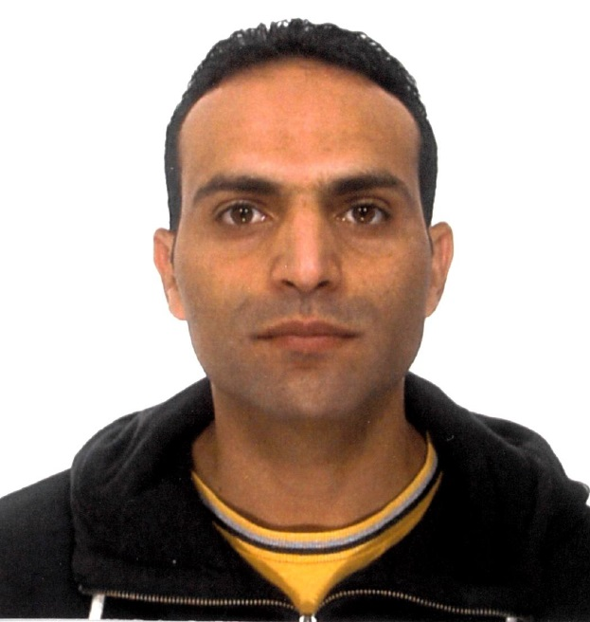

Soufiane BOUHADI

Address: Via Cesare Zuccardi Merli 12, 40141 Bologna, ITALY.
Email: Soufiane.bouhadi@gmail.com
Date of Birth: 06.11.1978.
Nationality: Moroccan / Italian
Marital status: Married.
Tel. +393208457799.

PROFILE
Senior .Net Developer

EDUCATION

- 2022: Bourgogne Franche-Comté University (France)
Studying for a master’s degree: Master 1: Informatique Avancée et Applications.

- 2020: Université Bourgogne Franche-Comté (France)
Bachelor’s degree in computer science.

- 2002: Technical Institute of Settat (Morocco)
Specialized Technician diploma in Programming and Maintenance of Automated Systems

certifications

- November 2016: MICROSOFT
Mirosoft Certified Solution Associate (MCSA)
 Web Applications

- November 2016: MICROSOFT
Mirosoft Specialist
 Programming in HTML5 with JavaScript and CSS3

- October 2016: MICROSOFT
Microsoft Certified Professional (MCP)
 Developing ASP.NET MVC Web Applications

- August 2016: W3C (World Wide Web Consortium)
Advanced Techniques for Designing HTML5 Apps

- August 2015: SCRUM.ORG
Professional Scrum Master 1 Certification

- May 2007: MICROSOFT
Microsoft Certified Professional (MCP)
 Microsoft Certification in Developing and Implementing Web
Applications with Visual Basic.Net and Visual Studio.Net.

- Aug 2006: MICROSOFT
Microsoft Certified Professional (MCP)
 Microsoft Certification in Developing and Implementing Windows
Based-Applications with Visual Basic.Net and Visual Studio.Net.

EXPERIENCE

- Mar 2018 up till now: PROMETEIA - ITALY (Risk Management, Financial Advisory, Business Consulting)
Senior .Net developer: Developing windows applications using C#, WPF, WCF, Entity Framework TDD and SQL.

- Sept 2015 – Feb 2018: PROMETEIA - ITALY (Risk Management, Financial Advisory, Business Consulting)
Senior .Net developer (IT consultant): Developing windows applications using C#, WPF, WCF, Entity Framework TDD and SQL.

- 2013 – Sept 2015: CRIF - ITALY (Business solutions for financial institutions)
Web developer (IT consultant): Developing and implementing web applications using ASP.NET and MVC.
Windows developer (IT consultant): Developing windows services, windows Forms, and console applications

- 2012: NOEMALIFE - ITALY (Healthcare software solutions)
Java and Flex developer (IT consultant): Developing an electronic prescribing software (e-Rx) according to the NHS
specifications

- 2007 – 2011: CRIF -ITALY (Business solutions for financial institutions)
Web developer (IT consultant): Developing and implementing web applications with ASP.NET
Windows developer (IT consultant): Developing windows services and console applications

- 2006: MAROC TELECOM - MOROCCO
Web developer: Developing and implementing internet portals and web sites using WEB FORMS

- 2003 - 2005: MOROCCAN FOOD PROCESSING - MOROCCO
Windows developer: Developing and implementing CMMS software using VB6
(Computerized Maintenance Management Systems).

SKILLS

- Developing and implementing Web applications with ASP.NET, WCF, MVC, C#, HTML5, CSS3, and
Javascript.
- Developing and implementing windows-based applications: WinForms, WPF.
- Programming Languages: C#, ASP.NET, Prolog, R, Java, PHP, JavaScript, TypeScript, Angular, T-
SQL, HTML5, CSS, XAML, XML, UML, XSLT, XSD, C, C++ and assembler.
- Databases: Oracle, MSSQL, MySQL.
- Developing Web services (WCF).
- Developing Web API
- XP (Extreme programming): Scrum, TDD…
- Programming microcontrollers and microprocessors (PICS, MOTOROLA…).

LANGUAGES

Native Arabic speaker.
Fluent French.
Fluent Italian.
Good English.
Basics in German (A1).

OTHER SKILLS

- Languages and tools for artificial Intelligence: PROLOG, ML.NET, WEKA, KNIME…
- Programming tools: Visual studio, Microsoft Team Foundation System (TFS), Eclipse, Tortoise SVN,
GitHub, PL-SQL, Jira, MS SQL Management Studio, RStudio.
- MERISE.
- Microsoft Office Suite.
- Operating systems: Windows, DOS.

iNTERESTS

- Electronic, Football.

